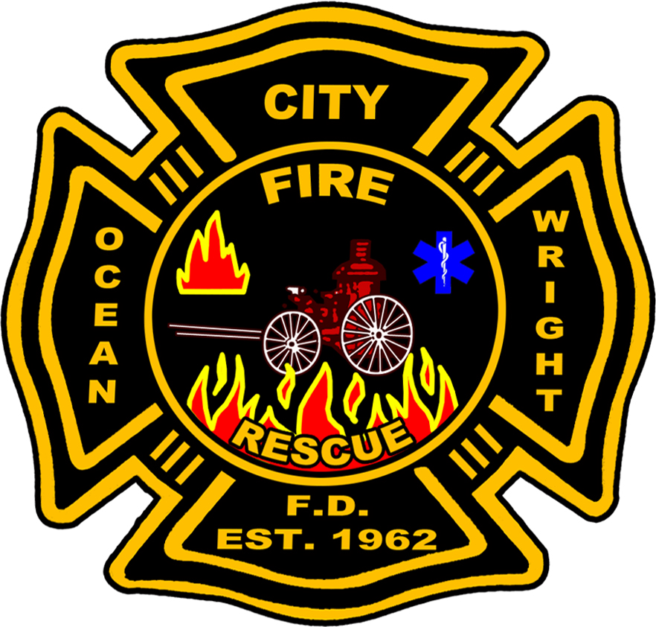
F Ocean City-Wright

Fire Control District

13 Jan 2026
MEMORANDUM FOR RECORD

FROM: Lincoln Williams, Assistant Chief
Accreditation Manager

SUBJECT: 2022-2027 Strategic Plan Progress

- Since the inception of the 2022-2027 Strategic Plan the district has steadily pursued the goals and objectives created by internal stakeholders to better support the communities of Ocean City, Wright, Shalimar, Cinco Bayou, and Mary Esther. The following assessment captures progress towards and the efforts made in 2025 to achieve those goals.

- Ocean City-Wright Fire Control District professionals focused on completing the remaining goals and objectives that were established in 2022. Our efforts culminated in the completion of the following components of the strategic plan:

  - Objective 1C, Eng/Capt/Batt Prep Course. The district developed the Step-up Driver Operator Course to prepare firefighters for the responsibility of serving as an engineer. The course delves deep into apparatus components, operation, and tactics. The objective is to develop our people, ensure high quality of maintenance, safeguard the community, and support emergency operations. This objective is still ongoing as it is the district’s position to create these courses for all levels of responsibility.

  - Objective 2D, Technology and Tool Procurement. The district staffed a committee to assess all tools and equipment to ensure that our personnel are well equipped to mitigate emergencies. The team identified aging extrication tools, apparatus appliances, rescue/search equipment, and thermal imagers that underperformed. The items were budgeted for and purchased to meet district needs. Additionally, the team forecasted replacement of a SCBA air compressor and SCBA bottles meeting the end of their service life. This objective is considered complete.

  - Objective 4C, Cancer Policy. One of the district’s battalion chiefs took on the task of researching best practices, coupled by state laws regarding cancer prevention for the district. They wrote and presented for approval a document that focuses on healthy practices to prevent carcinogen exposure. The document was approved and published for implementation. This objective is considered complete.

- In 2025 the district underwent the internal stakeholder process, Strength, Weakness, Opportunities, and Threats (SWOT) analysis to establish new goals that continue to align with our mission statement, core values and vision. The SWOT analysis garnered two new goals and added an objective to a previously established goal. The newly established Goal 7 involves expanding the districts service delivery capability in terms of water rescue, and Tactical Rescue. Goal 8 focuses on district readiness. The new objective ventures to create a training facility that can support all aspects of fire rescue.

Goal 2
Develop and improve OCWFCD facilities, vehicles, and equipment to provide the highest level of service to our community.

Objective 2E | Assess and renovate the district training facility to meet the robust training requirements of the Fire Service. (Added 30 May 2025)

Goal 7
Maximize current special operations capabilities and expand service delivery to exceed historical community incident mitigation demands.

Objective 7A | Expand community service delivery with a practical and capable water rescue program.
Objective 7B | Develop the OCWFCD TRT program into a viable, capable local response asset for emergency rescue operations that are outside of the scope of a single engine company response.

The district is dedicated to support the community in emergency situations. Through the SWOT analysis these capabilities were viewed as critical community needs.

- Objective 7A is well under way. The district has secured training for two individuals to be able to act as subject matter experts and provide district support as our advanced team to assess community need, identify equipment requirements, and establish water rescue protocols. The district will be purchasing a full complement of water rescue equipment and begin training the balance of the rescue team in May 2026.

- The pursuit of Objective 7B began with the acquisition of a new TRT trailer to house and transport equipment to an emergency special rescue incident.

Goal 8
Bolster district readiness by generating a large scale natural or manmade disaster preparedness plan that supports operations through the preparation, response, and recovery phases of community service.

Objective 8A | Create a comprehensive district emergency management plan that addresses district administrative and operational needs during large scale manmade or natural disasters.

This goal is a pursuit of sustainability in event of a large-scale disaster. Administrative and command sustainment are the focus to enable continued operations and prevent the loss of critical district data.

- Objective 8A is considered complete. This objective was found to be of the highest priority. The district administrative personnel scheduled and attended multiple meetings establishing contingency plans to support records preservation, duty schedules and logistics. The district is prepared to sustain operations.


LINCOLN T. WILLIAMS, Accreditation Manager
Ocean City-Wright Fire Control District

