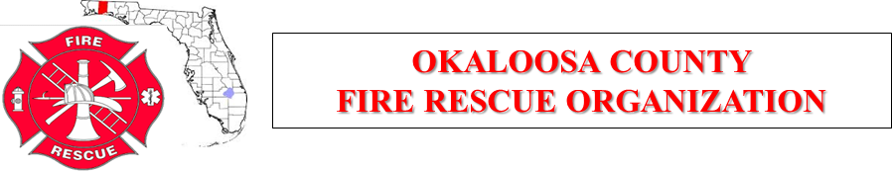

October 4, 2018

Meeting Minutes

Host: City of Fort Walton Beach Fire Department

Meeting called to order: 0905
Members Present: Perkins, Frank, Amos, Beasley, Giuliano, Bennett, Adair, Lee, Welborn, Wolfe, Lord, Funchess, Birch, Sasser, Carvalho, Strawn, Taylor, Mayville, James
Approval and Acceptance of the Agenda: Motion by Lord, Second by Sasser
Approval of Minutes of Last Meeting: Motion by Perkins, Second by Sasser
Approval of Financial Report: Motion by Lord, Second by Perkins

Special Guests: Allen OCSO, Abbott OCSO, Murphy OCPS

Old Business:
- Perkins PAT info
- PTSD information: Jeremy Hurd EMS Captain & Chaplain 561-254-7791 jhurd@pbcgov.org wpbchief@yahoo.com
- SMOKE training event at Hurlbert Field.
- Budget and Dues approve for 2019: Motion by Sasser, Second by Carvalho

New Business:
- Restructuring of JTC to have Hurlbert and Eglin added to provide information on training from the Air Force bases. Motion by Sasser, Second by Giuliano
- Purchase of rehab equipment by JTC. Covers and or EZ ups with hydration products (water, squenchers, coolers, etc) Motion by Sasser, Second by Bennett

Joint Training Committee Update: JTC quarterly training dates are November 6, 7, 8. Due to the training dates meeting is moved to November 5th. Motion by Lord, Second by Bennett

Select Committee: None

Okaloosa Public Safety:

- Murphy briefed of using new technology to utilize GPS and WIFI for patient identification and location. The Grant process for this will begin on December 1, 2018.
- Consolidation of the OCSO dispatch with the EMS and Fire dispatch is to begin on January 1, 2019.
- Group discussion with all members, county commissioner and OCSO representative Allen was conducted.

Good of the Organization:
- Amos stated Hurlburt will be putting on its S.M.O.K.E. training class in October. Fliers were emailed to everyone. He reminded everyone they are hosting class. Stated that there has been good response and that there is still slots available for the training.
- Perkins talked about the possible merger of Mary Esther Fire Department.
- Mayville mentioned the Mullet Festival will be on October 19-21 and the possible merger for Valparaiso Fire Department to the City of Niceville.
- Mayville went around the room to each member and gave them the opportunity to speak on any issues that they may have had. All was good.

Next Meeting: November 1, 2018 @ Okloosa County EOC, NWFSC

Meeting adjourned at: 1030 Motion by Lord, Second by Bennett

Recorder:

Lt Mike James

