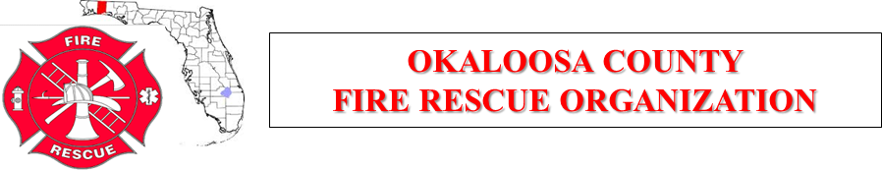

August 2, 2018
Meeting Agenda
Host: EOC

- Call to Order:

- Review and Acceptance of the Agenda:

- Review and Acceptance of Previous Meeting Minutes:

- Review and Acceptance of Current Financial Statements:

- Special Guest:

- Old Business:

- New Business:

  - Political Rally at NWFLSC Niceville Thursday night. (Mayville)

- Joint Training Committee:

- Select Committee:

- Okaloosa County Public Safety

- Good of the Organization:

- Next Meeting:

- Adjournment:

